PGSuper Plug-ins and Extensions

PGSuper supports plug-ins and extensions that can add extra functionality to the program. Plug-ins are easier to develop than extensions, but have limited capabilities. Extensions on the other hand are much more complicated but have virtually unlimited capabilities.

PGSuper supports three types of plug-ins; Project Importers, Data Importers, and Data Exporters. Project Importers integrate into the New Project dialog under the PGSuper Project Importers node. Project importers create a new PGSuper Project by importing data from an external data source such as a database or data file from another similar application.

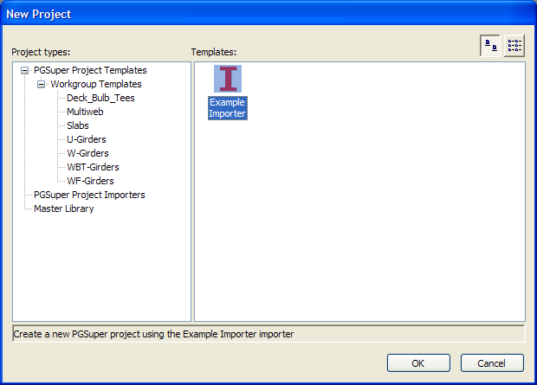

PGSuper Data Importers differ from Project Importers in that they import data into an open project. Data Imports are found on the File | Import menu. PGSuper Data Exporters are found on the File | Export menu. They can be used to export data from PGSuper to an external data source such as a database, file, or another application. Plug-ins are limited to these simple tasks.

Extensions integrate into the PGSuper interface in many different ways and can offer the user many different capabilities. An extension can add commands to a menu, add new drop-down menus, add buttons to toolbars and add new toolbars, can add any type of view displaying any type of data, and can read and write extension-specific data. Extensions can also add new report types into the PGSuper reporting system including reports that need specialized user interfaces to edit reporting parameters.